Energy crisis in Europe revamps the economic competitiveness of green chemicals
Abhinandan Nabera, Ioan-Robert Istrate, Javier Pérez-Ramírez and Gonzalo Guillén-Gosálbez*
Institute for Chemical and Bioengineering, Department of Chemistry and Applied Biosciences, ETH Zürich, Vladimir-Prelog-Weg 1, Zürich 8093, Switzerland
*Corresponding author: gonzalo.guillen.gosalbez@chem.ethz.ch

Context and scale
Ammonia and methanol are two of the most important chemicals which are used in our daily lives. Both these chemicals majorly use natural gas as a feedstock for their production which results in higher CO₂ emissions. A variety of research has been carried out in abundance to produce these chemicals in a more environmentally sustainable manner. However, the economics of such alternative routes of production was found to be infeasible. Nonetheless, the current scenario in Europe paints a different picture when natural gas prices become volatile. In this work, a cost-benefit analysis of the changing production costs for fossil ammonia and methanol is compared with the greener routes of production as a result of the current state of affairs in Europe. In addition to emitting less CO₂, the alternative routes of production were found to be cost competitive and, in some cases, even cheaper than their fossil counterparts.

Summary
Green hydrogen produced via water electrolysis using renewable electricity sources is a possible alternative to lower greenhouse gas (GHG) emissions related to ammonia and methanol production. However, the economics of green hydrogen acts as a bottleneck making this route infeasible. Here, we show that these alternative routes of production become economically feasible in the current scenario where natural gas prices are skyrocketing majorly due to the geopolitical outline. Green ammonia produced from hydrogen via water electrolysis using on-shore wind electricity was found to be economically competitive or similar (<5%) to the fossil route for nine months since October 2021. The lowest feasible monthly average production cost for wind-based ammonia was around 1,166 USD t⁻¹ in October 2021 in comparison to 1,155 USD t⁻¹ for the fossil route. Similarly, wind-based methanol was found to be economically feasible in comparison to fossil methanol for one month during the peak of natural gas prices in Europe. This study makes us realize the importance and need of the hour to invest in alternative routes for the production of chemicals starting with ammonia and methanol.

Introduction
The chemical industry is the industrial sector with the highest energy demand as it uses fossil fuels both as feedstock and fuel. About 14% and 8% of global oil and gas, respectively, are consumed by the chemical industry¹, which is also responsible for 5.6 Gt CO₂-eq year⁻¹ (including direct and indirect emissions), equivalent to roughly 10% of global anthropogenic greenhouse gas (GHG) emissions^{2,3}. Out of all the chemicals, ammonia, methanol, ethylene, and propylene are the major building blocks of the chemical industry which are further used as raw materials for the production of valuable products. Notably, ammonia is critical to the production of mineral nitrogen fertilizers and to ensure global food security^{4,5}, while methanol is largely used for the production of valuable products (e.g., formic acid, acetic acid, dimethyl ether, and methylamine) and can serve as an intermediate to olefins and aromatics^{1,6}. Ammonia is predominantly produced from hydrogen and nitrogen via the Haber-Bosch process. About 70% of global ammonia production uses natural gas as feedstock, being responsible for about 20% of the industrial natural gas demand and ca. 520 Mt CO₂-eq year⁻¹ over the life cycle⁷. Similarly, 65% of global methanol relies on natural gas for the production of syngas which is then converted to methanol via the water-gas shift reaction⁸. The life cycle GHG emissions from global methanol production are around 300 Mt CO₂-eq year⁻¹.⁸
Current GHG emissions levels of ammonia and methanol production are largely incompatible with climate goals and the planetary boundary for climate change^{9,10}. Ammonia and methanol are what is known as a hard-to-abate commodity primarily due to their strong dependence on natural gas as feedstock. Thus, shifting to renewable feedstocks becomes paramount to mitigate their climate impacts^{11,12}. Low-carbon ammonia production is possible by switching the hydrogen source from natural gas to water electrolysis powered by renewable energy sources like wind or solar^{7,13}. Moreover, carbon capture and utilization (CCU) offers a route to defossilize methanol production via CO₂ hydrogenation⁸. Prior works have demonstrated the technical feasibility^{7,13–15} and potential climate benefits^{9,16–18} of a green chemical industry, but the high costs remain a major barrier¹⁹. Literature estimates suggest that green ammonia and methanol cost twice as much as the natural gas-based counterpart^{9,10}.
The economic competitiveness of green chemicals has been largely hampered by the high costs of renewable feedstocks (i.e., renewable hydrogen and captured CO₂) compared with natural gas^{9,10}. However, natural gas has seen a sharp increase in prices over the last two years, primarily due to the COVID-19 pandemic, skyrocketing inflation, and the global energy crisis caused by the Russian invasion of Ukraine. Energy supplies disruption as a result of the new geopolitical scenario has severely affected Europe, where monthly average natural gas spot prices (i.e., prices for new contracts at the Title Transfer Facility (TTF) trading point) have increased from 560 USD t⁻¹ in July 2021 to 2,300 USD t⁻¹ as of July 2022, while the price of grid electricity has almost quadrupled²⁰. The drastic increase in natural gas and electricity prices has severe consequences for the European chemical industry²¹. Recent news suggests that more than half of Europe’s ammonia production capacity (estimated at around 19 Mt year⁻¹)¹³ has been shut down due to gas prices^{22,23}.
The energy crisis in Europe could in principle improve the economic competitiveness of green ammonia and methanol while laying the foundation for a renewable transition in the European chemical industry. However, while the potential climate benefits have been proven, whether green chemicals can also reduce costs in the present state of affairs has not been explored yet. We fill this critical research gap by estimating the production costs for fossil and green ammonia and methanol in Europe considering the fluctuation in natural gas and electricity prices due to the global energy crisis. For ammonia production, we investigate the Haber-Bosch process considering four typical hydrogen sources¹³: i) grey hydrogen from steam methane reforming (SMR) using natural gas, ii) green hydrogen from water electrolysis using on-shore wind electricity, iii) green hydrogen from water electrolysis using solar photovoltaic (PV) electricity, and iv) blue hydrogen from SMR coupled with carbon capture and storage (CCS). Similarly, we compare four alternative production routes for methanol: i) conventional synthesis from natural gas, ii) synthesis from captured CO₂ and wind-based electrolytic hydrogen, iii) synthesis from captured CO₂ and solar PV-based electrolytic hydrogen, and iv) synthesis from captured CO₂ and blue hydrogen –SMR coupled with CCS–. In all cases, we consider that CO₂ is extracted from the atmosphere by direct air capture (DAC) as this option shows a high potential to reduce GHG emissions with reduced risk of burdens shifting¹⁶. Further details of production routes are presented in the Experimental procedures.

Results

Production costs for fossil ammonia and methanol
Considering the natural gas spot prices in Europe, we estimate that the production cost for fossil ammonia has increased from an average of XX USD t⁻¹ in the period 2019-2020 to 1,344 USD t⁻¹ as of November 2022 (Fig. 1a). Similarly, the cost of production for fossil methanol has reached 1,181 USD t⁻¹ in November 2022, compared with XX USD t⁻¹ in the period 2019-2020 (Fig. 1b). Natural gas spot prices and chemicals production costs have increased steadily since 2020 due to the rising inflation as a consequence of the COVID-19 pandemic. Since February 2022, following the Russian invasion of Ukraine, natural gas prices have fluctuated considerably, and so did the production costs. For example, ammonia production cost ranges from XXX USD t⁻¹ in February 2022 to as high as XXX USD t⁻¹ in August 2022 (peak of natural gas spot prices). Overall, in comparison to July 2021, the estimated production cost for fossil ammonia and methanol rose by 200% and 146%, respectively, in November 2022.
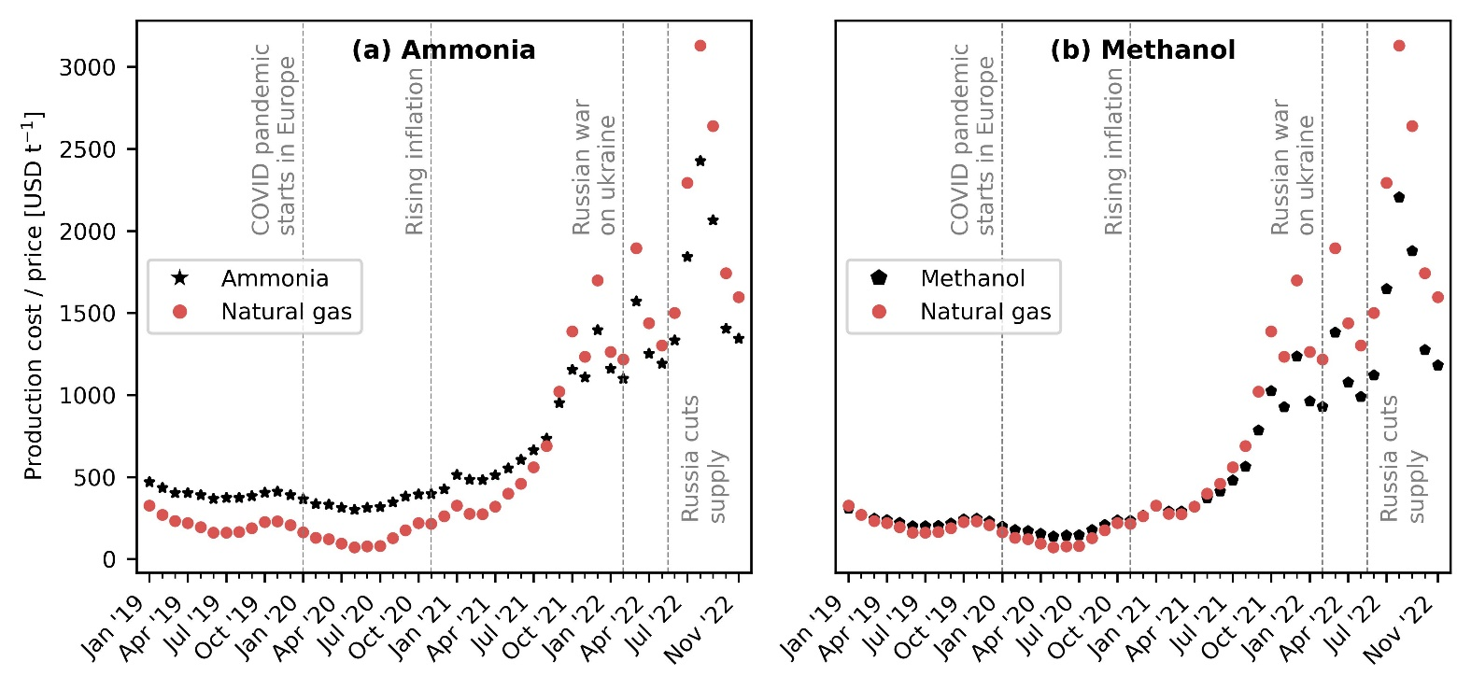
Fig. 1 Evolution of natural gas spot prices and production costs for fossil ammonia and methanol in Europe. (a) Fossil ammonia production via the Haber-Bosch process with grey hydrogen from steam methane reforming (SMR) using natural gas. (b) Fossil methanol synthesis from natural gas. The estimated production costs consider the fluctuation in natural gas and electricity prices due to the global energy crisis.

Economic competitiveness of green ammonia and methanol production routes
We next study the economic competitiveness of green production routes for ammonia and methanol. Green ammonia produced with hydrogen from water electrolysis using wind electricity turns cost-competitive at natural gas prices of around 1,400 USD t⁻¹. Hence, we find that ammonia production via wind electrolysis has been cheaper than or similar to fossil ammonia for nine months since October 2021 (Fig. 2a). Within this period, the production costs ranged from XXX to XXX USD t⁻¹ ammonia. Whereas green ammonia produced via solar PV-based electrolytic hydrogen is only competitive around the peak of natural gas spot prices in August 2022 (Fig. 2b). This can be attributed to lower capacity factors solar PV (16.1 to 17.5%) in comparison to wind electricity (35.6% to 39%) resulting in higher levelized costs of hydrogen²⁴. Ammonia production with blue hydrogen –SMR coupled with CCS– is always more expensive than the conventional route due to the additional cost of CCS and extra nitrogen feed (Fig. 2c).
Green methanol produced with DAC CO₂ and wind-based electrolytic hydrogen is economically competitive at natural gas prices of around 3,100 USD t⁻¹ (Fig. 2d). However, the break-even natural gas price largely depends on the levelized cost of hydrogen and could decrease to 2,300 USD t⁻¹ if considering the lower end of the hydrogen cost range. Thus, methanol production via DAC CO₂ and wind electrolysis has been cheaper than or similar to fossil methanol for one and three months since October 2021 if considering the average and lower end of hydrogen cost, respectively. The solar-based route is never feasible even at the peak of natural gas prices (Fig. 2e). For the case of methanol production from DAC CO₂ and blue hydrogen, the cost of production is on average 182% higher than fossil methanol due to the additional cost of CCS and captured CO₂ (Fig. 2f).
To investigate further, Fig. 3 shows the breakdown of production costs for fossil and wind-based chemicals production at different time points. We take average values for the years 2019 and 2020 as the natural gas and electricity prices before July 2021 were approximately constant. Notably, the contribution of natural gas to the average production cost for fossil ammonia increased from 21% in 2020 to 44% in July 2021 and up to 63% in November 2022 (Fig. 3a). Similarly, the contribution of electricity increased from 8% in 2020 to 12% in November 2022. For green ammonia, wind-based electrolytic hydrogen has the highest share of the production cost (67% to 84%). Moreover, since wind electricity is used only for the electrolyzer, whereas for the compressors we consider grid electricity, the share of grid electricity rose from ∼1% in 2020 to 6% in November 2022.
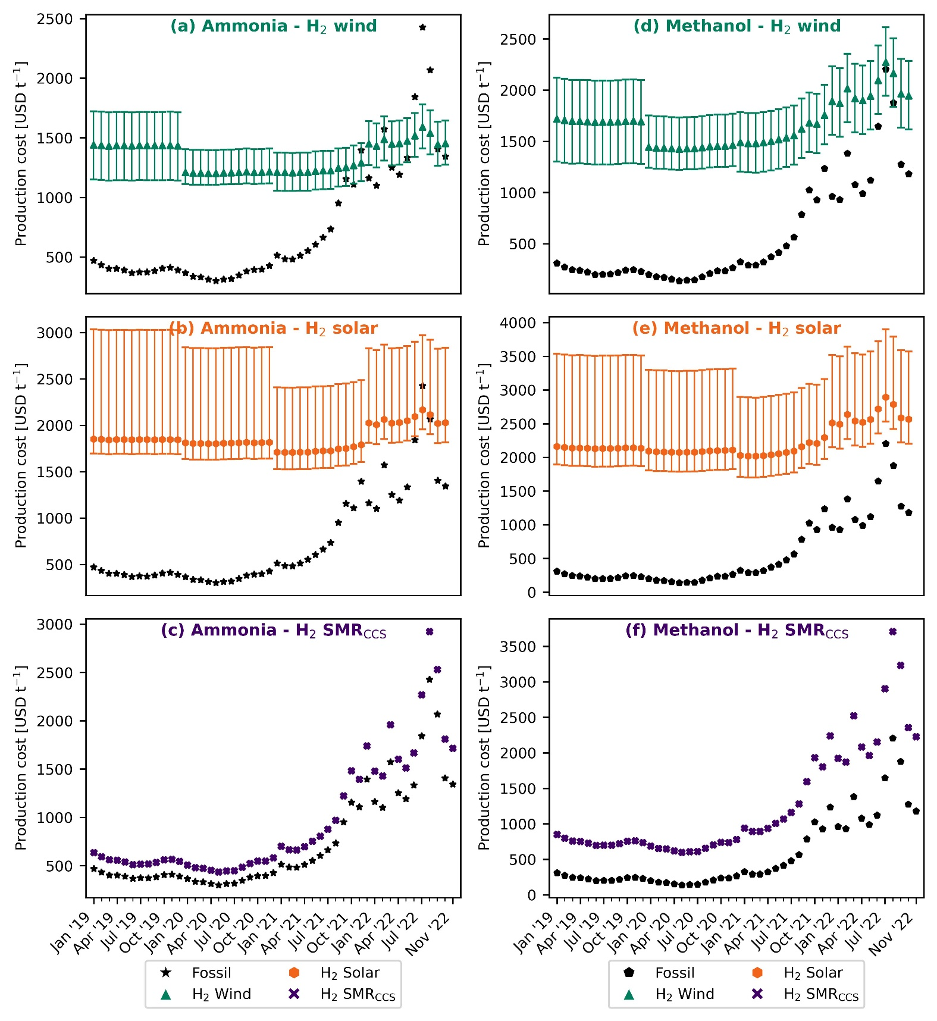
Fig. 2 Evolution of the production costs for green ammonia and methanol in Europe compared with the fossil (natural gas-based) counterpart. Green ammonia production based on the Haber-Bosch process with green hydrogen from water electrolysis using on-shore wind electricity (a) or solar photovoltaic (PV) electricity (b) and blue hydrogen from steam methane reforming (SMR) coupled with carbon capture and storage (CCS) (c). Methanol synthesis from captured CO₂ and wind-based electrolytic hydrogen (d), PV-based electrolytic hydrogen (e) or blue hydrogen –SMR coupled with CCS– (f). The estimated production costs considering the fluctuation in natural gas and electricity prices due to the global energy crisis. Error bars display the production cost considering the lower and upper bound for the levelized cost of hydrogen.
Similarly, for the production of fossil methanol, the share of natural gas increased from 48% in 2020 to 76% in July 2021, and 88% in November 2022 (Fig. 3b). The contribution of electricity stood at around ∼1% during the entire period considered in our analysis. For the green methanol production route, hydrogen from wind electrolysis has the highest share of around 65% in July 2021 which decreased to 58% in November 2022. The share of CO₂ from DAC was about 17% in 2020 and increased to 29% in November 2022. This increase can be attributed to the increase in natural gas prices which is required for the capture of CO₂ via DAC.
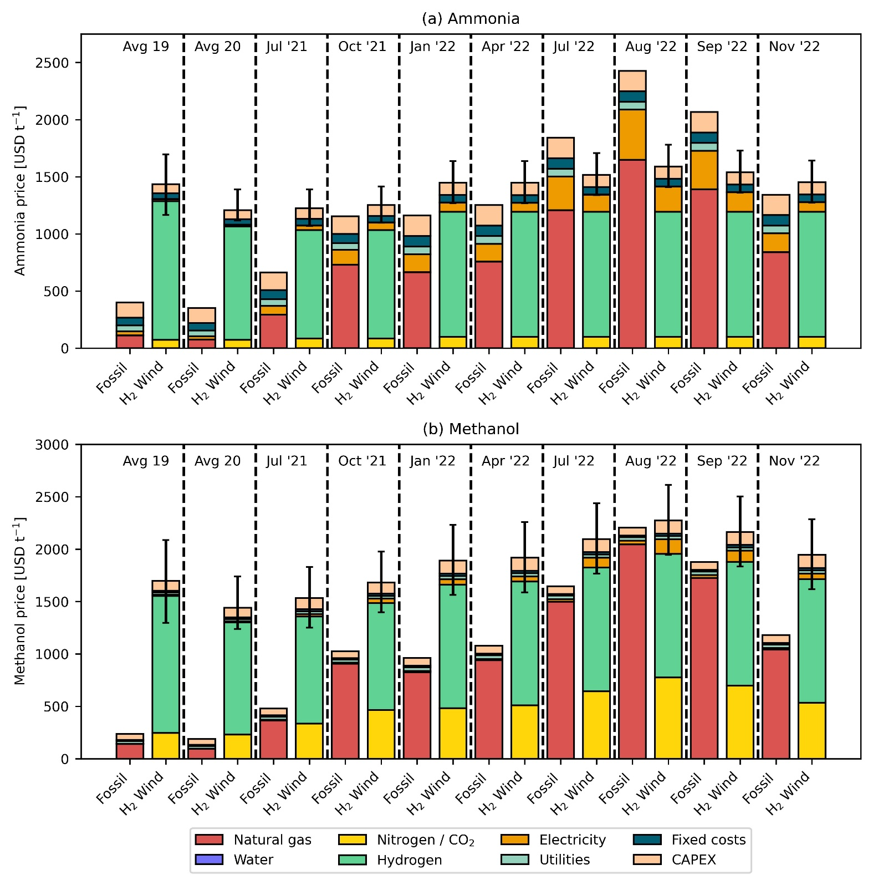
Fig. 3 Breakdown of production costs for fossil and green ammonia (a) and methanol (b). Green ammonia production route based on hydrogen from water electrolysis using on-shore wind electricity. Green methanol production route based on wind-based electrolytic hydrogen and captured CO₂ from direct air capture (DAC). Error bars display the production cost considering the lower and upper bound for the levelized cost of hydrogen.

Avoidance costs
After revealing that green chemicals production routes could be economically appealing, we next analyse the avoidance cost, which provide the economic viability of climate change mitigation. The avoidance cost follows an inverse trend to the natural gas price. In 2020 at an average natural gas price of 145 USD t⁻¹, wind- and solar-based ammonia result in an avoidance cost of 513 and 1,259 USD t⁻¹ CO₂-eq, respectively (Fig. 4a). This cost is substantially higher for methanol with 1,327 and 7,104 USD t⁻¹ CO₂-eq, respectively (Fig. 4b), primarily due to a higher difference between the production costs of fossil and green methanol. Notably, the avoidance cost of green ammonia and methanol in 2020 largely surpasses the removal cost of bioenergy with carbon capture and storage (BECCS) and DAC with carbon capture and storage (DACCS), forecasted at 100-200 USD t⁻¹ CO₂ and 100-300 USD t⁻¹ CO₂, respectively²⁵. However, as natural gas prices increase, less money is required for every ton of CO₂ emission avoided by switching from fossil to green chemicals. At the peak of natural gas prices in 2022, the avoidance cost of green ammonia and methanol becomes negative, meaning that the industry could simultaneously reduce costs and GHG emissions. Since July 2021, the industry could save around 123 to 625 USD t⁻¹ CO₂-eq avoided via the wind-based route for ammonia production. Similarly, in August 2022 for methanol via wind, savings stood at around 46 USD t⁻¹ CO₂-eq avoided.
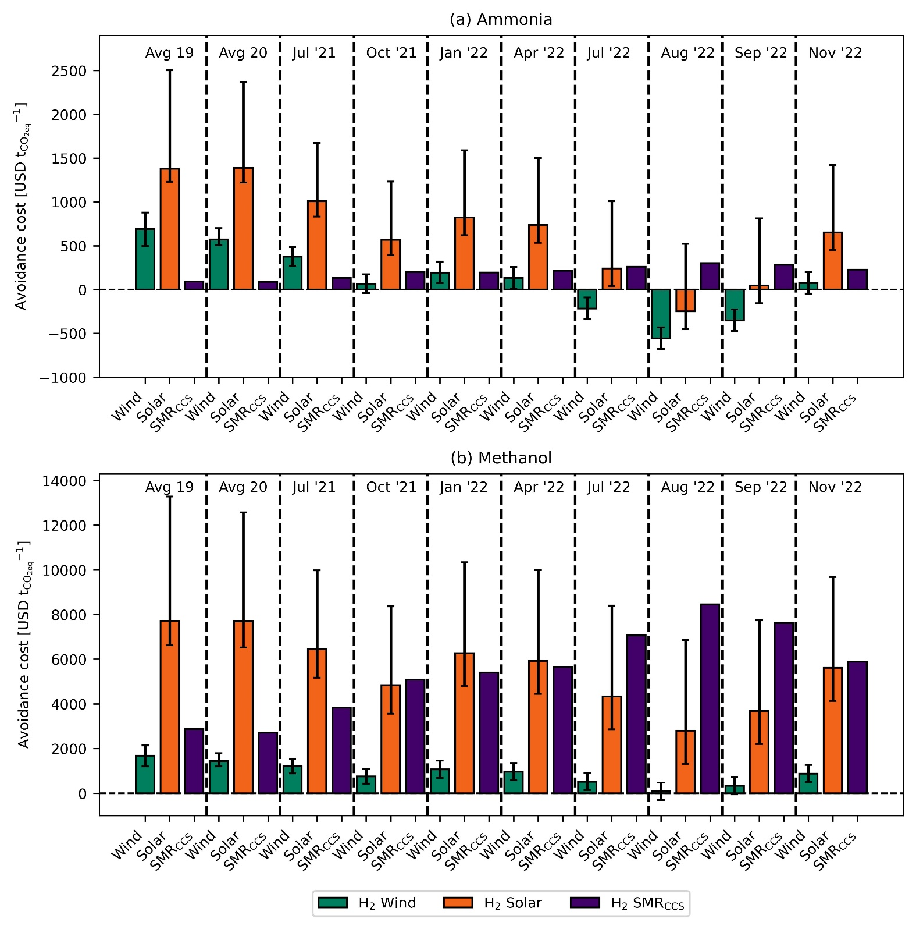
Fig. 4 CO₂ avoidance costs for green ammonia (a) and methanol (b). Error bars display the production cost considering the lower and upper bound for the levelized cost of hydrogen.

Discussion
Here we have shown how an unprecedented crisis of soaring natural gas and electricity prices in Europe has improved the economic competitiveness of green chemicals production. Notably, we found that ammonia production via hydrogen from water electrolysis using on-shore wind electricity has generally outperformed natural gas-based ammonia since October 2021. Whether green ammonia will remain economically competitive will depend mainly on the evolution of natural gas prices, which in turn depend on the duration of the war in Ukraine and the adopted measures to diversify gas suppliers (e.g., increased imports of more expensive liquified natural gas). Between December 2022 and January 2023, favourable weather and lower demand from the industry have helped reduce the natural gas prices back to levels before the Russian invasion of Ukraine²⁶. However, even these price levels are higher than the break-even natural gas price that enables cost-competitive ammonia production from wind electrolysis, which we estimated at 1,400 USD t⁻¹. In 2023, considering zero supply from Russia, unpredictable weather conditions, and increasing competition for liquified natural gas, securing natural gas supplies could be a conundrum²⁷. Hence, the World Bank forecasts that natural gas prices are expected to moderate in 2023, but will certainly remain well above the average prices registered before 2020²⁰. Other source²⁸ predicts that the natural gas spot price in Europe will remain in the range 1,579 - 2,216 USD t⁻¹. At the same time, the costs of renewable energy technologies –including wind power and electrolyzers– are expected to decline as a result of the experience effect²⁹. For these reasons, we argue that ammonia production from wind-based electrolytic hydrogen is expected to be cost-competitive in the foreseeable future.
The production costs of chemicals have been historically higher in Europe than in other regions like U.S., Russia, or Saudi Arabia, primarily due to higher labour and feedstock costs³⁰. The disruption of the global energy market in 2022 had further exacerbate this gap, since other regions have faced less fluctuation in energy prices due to a lower dependence on imports²⁰. For example, between 2020 and 2022 the natural gas price has increased by a factor of 1.6 in the U.S. compared with a factor of 9.6 in Europe²⁰. Within this context, one may argue that the chemical industry will look to shift production to regions with low-cost labour and feedstocks, instead of establishing green production routes. However, such relocation would come at the expense of tremendous socio-economic consequences for Europe. In 2020, Europe has been the second largest chemicals producer in the world³¹. Given the pivotal role of chemicals across many supply chains, shifting production would mean losing a strategic position while exposing Europe to vulnerability to supply disruption. This aspect is of high importance for ammonia due to its paramount role in ensuring food security⁵. Moreover, chemical companies generate about 1.2 million jobs across Europe³¹, which could be lost with production relocation.
In addition to ensure supply security, green ammonia and methanol could help the European chemical industry to reduce GHG emissions at a negative mitigation cost, i.e., the industry could save money per each unit of CO₂ avoided. Achieve the goal of becoming climate neutral by 2050³¹???.
Overall, our findings suggest that rising energy prices in Europe can make green ammonia and methanol production routes cost-competitive, thereby overcoming the major barrier to their implementation (i.e., the high costs compared with fossil routes). This represents a unique opportunity for the European chemical industry to shift to renewable feedstocks to simultaneously reduce costs and GHG emissions. Such transition would also have great benefits for European economies by scurrying the supply of key commodities that are imperative to ensure food security (i.e., ammonia) and to support the energy transition (i.e., methanol). Moreover, by producing locally the renewable feedstocks (i.e., hydrogen and captured CO₂), Europe would further reduce the dependence on imports and its vulnerability to market shocks. However, the debate remains open concerning the potential future dependence of Europe on critical raw materials imports to materialize a full transition towards renewable energy technologies³².

Experimental procedures
Production routes definition. ……
Economic assessment. The material balances and energy flows for both fossil and green ammonia are extracted from the work done by D’Angelo et al.⁹. In the case of fossil ammonia, every ton of ammonia produced consumes 0.53 tons of natural gas and 940 kWh of electricity. The prices of feedstock and utilities other than natural gas, electricity, and hydrogen are extracted from D’Angelo et al.⁹ and adjusted for inflation. The monthly average natural gas TTF spot prices from World Bank²⁷ and electricity prices from Ember¹⁶ are used for all our calculations. Further, the levelized cost for on-shore wind and solar electricity and their corresponding capacity factors are extracted from IRENA for the years 2019 to 2021 (except 2022)^{28,29,30}. Using these values, the levelized cost of hydrogen (LCOH) is calculated following the assumptions and equations provided in the work carried out by D’Angelo et al.⁹. Due to the lack of availability of similar data for the year 2022, the levelized cost of electricity (LCOE) is adjusted with inflation to calculate the LCOH for the specific year. Similarly for methanol, the material balance and energy flow for both fossil methanol and green methanol are extracted from González-Garay et al.¹⁰. Every ton of fossil methanol produced consumes 0.65 tons of natural gas and 74 kWh of electricity. The prices of natural gas, electricity, and hydrogen are substituted by the aforementioned extracted and or calculated prices, and all the other costs are adjusted for inflation. The price of CO₂ from DAC is extracted from Keith et al.²⁶ and recalculated with the new natural gas prices. For every ton of CO₂ captured, 0.11 tons of natural gas is required²⁶.
Avoidance costs. The CO₂ avoidance costs in USD t⁻¹CO_{2eq} are calculated as follows:
$${\text{CO}}_{\text{2}}\text{ avoidance costs [}\frac{\text{USD}}{{\text{t}}_{{\text{CO}}_{\text{2eq}}}^{\text{-1}}}\text{] =} \frac{{\text{P.C}}_{\text{ALT}}\text{ -} {\text{P.C}}_{\text{BAU}}}{{\text{GWP}}_{\text{BAU}}\text{ -} {\text{GWP}}_{\text{ALT}}}$$
where P.C_{BAU/ALT} represents the production cost in USD t⁻¹ for the fossil (BAU) and alternative (ALT) routes. Similarly, GWP_{BAU/ALT} represents the global warming potential in t_{CO2eq} t⁻¹ for the fossil (BAU) and alternative (ALT) routes of production.

References
1. IEA (2018). The Future of Petrochemicals: Towards more sustainable plastics and fertilisers (International Energy Agency).
2. Bauer, F., Tilsted, J.P., Pfister, S., Oberschelp, C., and Kulionis, V. (2023). Mapping GHG emissions and prospects for renewable energy in the chemical industry. Current Opinion in Chemical Engineering 39, 100881. 10.1016/j.coche.2022.100881.
3. Bauer, F., Kulionis, V., Oberschelp, C., Pfister, S., Tilsted, J.P., Finkill, G.D., and Fjäll, S. (2022). Petrochemicals and Climate Change: Tracing Globally Growing Emissions and Key Blind Spots in a Fossil-Based Industry (Lund University).
4. Erisman, J.W., Sutton, M.A., Galloway, J., Klimont, Z., and Winiwarter, W. (2008). How a century of ammonia synthesis changed the world. Nature Geosci 1, 636–639. 10.1038/ngeo325.
5. Rosa, L., and Gabrielli, P. (2022). Energy and food security implications of transitioning synthetic nitrogen fertilizers to net-zero emissions. Environ. Res. Lett. 18, 014008. 10.1088/1748-9326/aca815.
6. Olah, G.A. (2005). Beyond Oil and Gas: The Methanol Economy. Angewandte Chemie International Edition 44, 2636–2639. 10.1002/anie.200462121.
7. IEA (2021). Ammonia Technology Roadmap: Towards more sustainable nitrogen fertiliser production (OECD) 10.1787/f6daa4a0-en.
8. IRENA (2021). Innovation Outlook: Renewable Methanol.
9. D’Angelo, S.C., Cobo, S., Tulus, V., Nabera, A., Martín, A.J., Pérez-Ramírez, J., and Guillén-Gosálbez, G. (2021). Planetary Boundaries Analysis of Low-Carbon Ammonia Production Routes. ACS Sustainable Chem. Eng. 9, 9740–9749. 10.1021/acssuschemeng.1c01915.
10. González-Garay, A., Frei, M.S., Al-Qahtani, A., Mondelli, C., Guillén-Gosálbez, G., and Pérez-Ramírez, J. (2019). Plant-to-planet analysis of CO₂ -based methanol processes. Energy Environ. Sci. 12, 3425–3436. 10.1039/C9EE01673B.
11. Schiffer, Z.J., and Manthiram, K. (2017). Electrification and Decarbonization of the Chemical Industry. Joule 1, 10–14. 10.1016/j.joule.2017.07.008.
12. Lange, J.-P. (2021). Towards circular carbo-chemicals – the metamorphosis of petrochemicals. Energy Environ. Sci. 14, 4358–4376. 10.1039/D1EE00532D.
13. Ausfelder, F., Herrman, E.O., and López González, L.F. (2022). Technology options for CO2-emission reduction of hydrogen feedstock in ammonia production (DECHEMA Gesellschaft für Chemische Technik und Biotechnologie e.V).
14. IEA (2013). Technology Roadmap Energy and GHG Reductions in the Chemical Industry via Catalytic Processes (International Energy Agency).
15. Huo, J., Wang, Z., Oberschelp, C., Guillén-Gosálbez, G., and Hellweg, S. (2023). Net-zero transition of the global chemical industry with CO2-feedstock by 2050: feasible yet challenging. Green Chem. 25, 415–430. 10.1039/D2GC03047K.
16. Galán-Martín, Á., Tulus, V., Díaz, I., Pozo, C., Pérez-Ramírez, J., and Guillén-Gosálbez, G. (2021). Sustainability footprints of a renewable carbon transition for the petrochemical sector within planetary boundaries. One Earth 4, 565–583. 10.1016/j.oneear.2021.04.001.
17. Ioannou, I., Galán-Martín, Á., Pérez-Ramírez, J., and Guillén-Gosálbez, G. (2022). Trade-offs between Sustainable Development Goals in carbon capture and utilisation. Energy Environ. Sci. 10.1039/D2EE01153K.
18. Kätelhön, A., Meys, R., Deutz, S., Suh, S., and Bardow, A. (2019). Climate change mitigation potential of carbon capture and utilization in the chemical industry. Proceedings of the National Academy of Sciences 116, 11187–11194. 10.1073/pnas.1821029116.
19. Hepburn, C., Adlen, E., Beddington, J., Carter, E.A., Fuss, S., Mac Dowell, N., Minx, J.C., Smith, P., and Williams, C.K. (2019). The technological and economic prospects for CO2 utilization and removal. Nature 575, 87–97. 10.1038/s41586-019-1681-6.
20. The World Bank (2022). Commodity Markets Outlook: The Impact of the War in Ukraine on Commodity Markets (The World Bank Group).
21. cefic (2022). Chemical Monthly Report (CMR) - High energy prices and economic uncertainty continue to drive down the chemicals output in the EU27 area (European Chemical Industry Council).
22. de Sousa, A., Gebre, S., and Treloar, S. (2022). Europe’s Widening Fertilizer Crisis Threatens Food Supplies. Bloomberg.com.
23. Lopez, J. (2022). EPCA ’22: European shut ammonia production unlikely to return - analyst. ICIS Explore. https://www.icis.com/explore/resources/news/2022/10/04/10811649/epca-22-european-shut-ammonia-production-unlikely-to-return-analyst.
24. IRENA (2021). Making the breakthrough: Green hydrogen policies and technology costs (International Renewable Energy Agency).
25. Fuss, S., Lamb, W.F., Callaghan, M.W., Hilaire, J., Creutzig, F., Amann, T., Beringer, T., Garcia, W. de O., Hartmann, J., Khanna, T., et al. (2018). Negative emissions—Part 2: Costs, potentials and side effects. Environ. Res. Lett. 13, 063002. 10.1088/1748-9326/aabf9f.
26. The World Bank (2023). Commodity Markets. https://www.worldbank.org/en/research/commodity-markets.
27. IEA (2022). How to Avoid Gas Shortages in the European Union in 2023.
28. CME Group (2023). Dutch TTF Natural Gas Calendar Month Futures Quotes. https://www.cmegroup.com/markets/energy/natural-gas/dutch-ttf-natural-gas-calendar-month.quotes.html.
29. Way, R., Ives, M.C., Mealy, P., and Farmer, J.D. (2022). Empirically grounded technology forecasts and the energy transition. Joule 6, 2057–2082. 10.1016/j.joule.2022.08.009.
30. Boulamanti, A., and Moya, J.A. (2017). Production costs of the chemical industry in the EU and other countries: Ammonia, methanol and light olefins. Renewable and Sustainable Energy Reviews 68, 1205–1212. 10.1016/j.rser.2016.02.021.
31. cefic (2022). The European Chemical Industry - Facts & Figures 2022.
32. Sovacool, B.K., Ali, S.H., Bazilian, M., Radley, B., Nemery, B., Okatz, J., and Mulvaney, D. (2020). Sustainable minerals and metals for a low-carbon future. Science 367, 30–33. 10.1126/science.aaz6003.

